📝 Power BI – Module End Evaluation
Fathima Sabeeha
Batch 69Q1: Data Cleaning and Loading
- Import the dataset into Power BI using Power Query Editor.
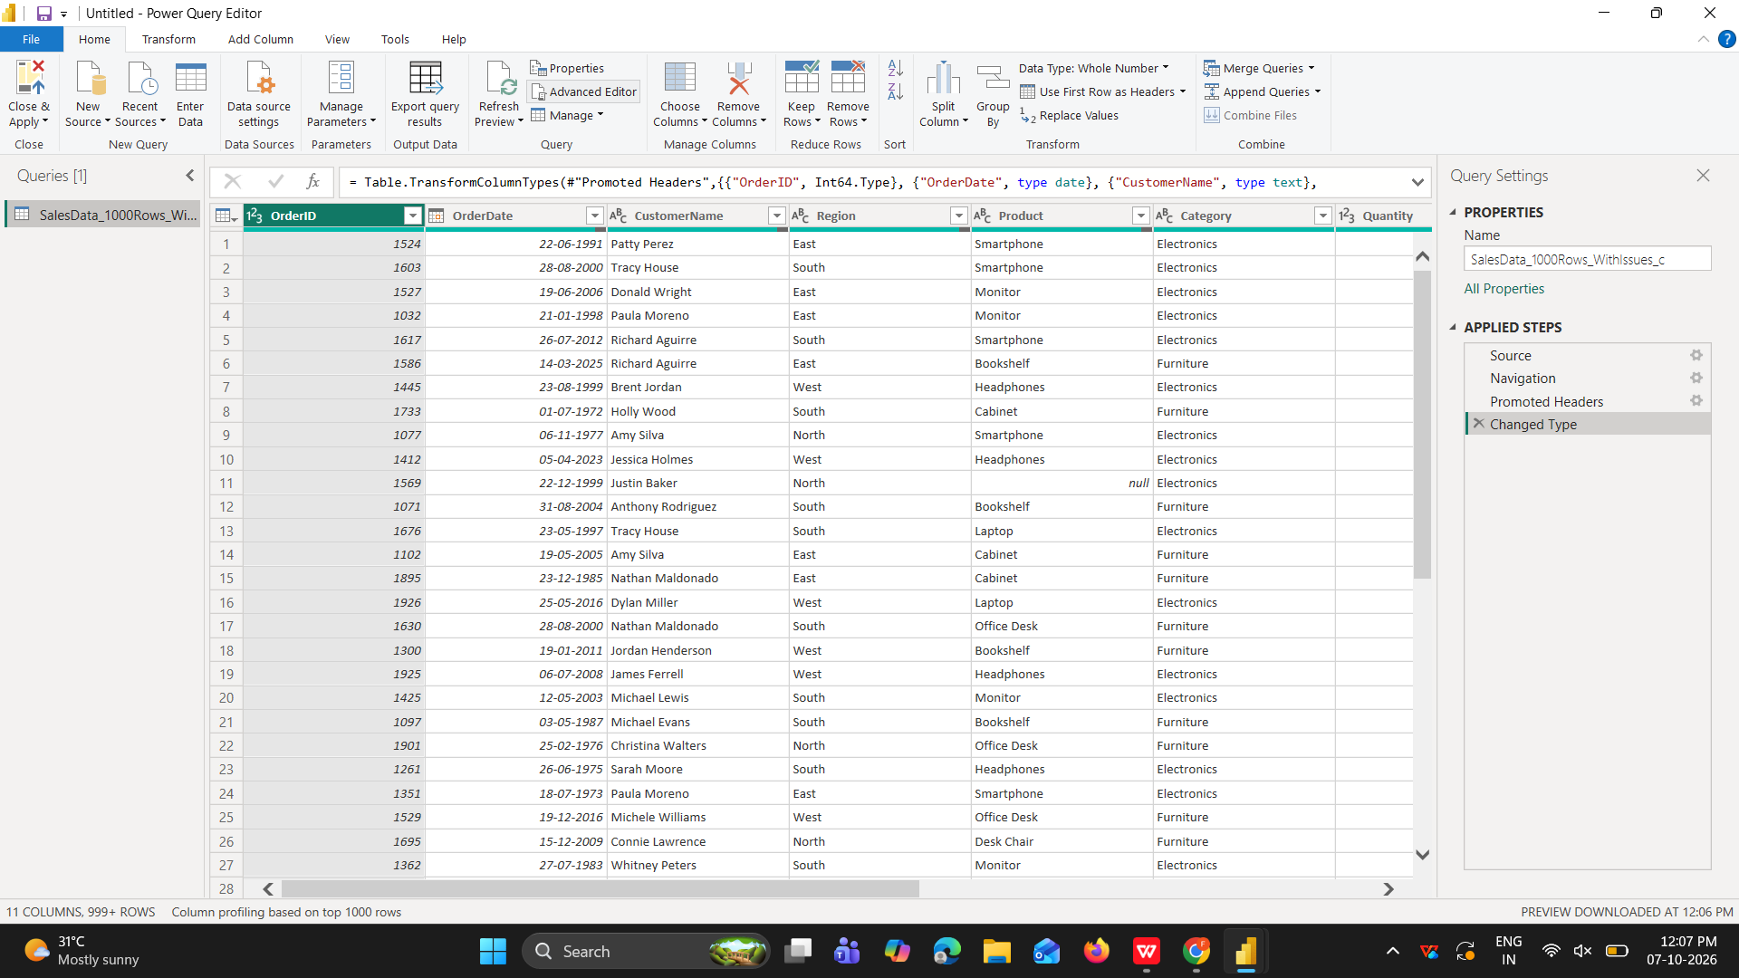
- data cleaning
- Handling missing values in columns.

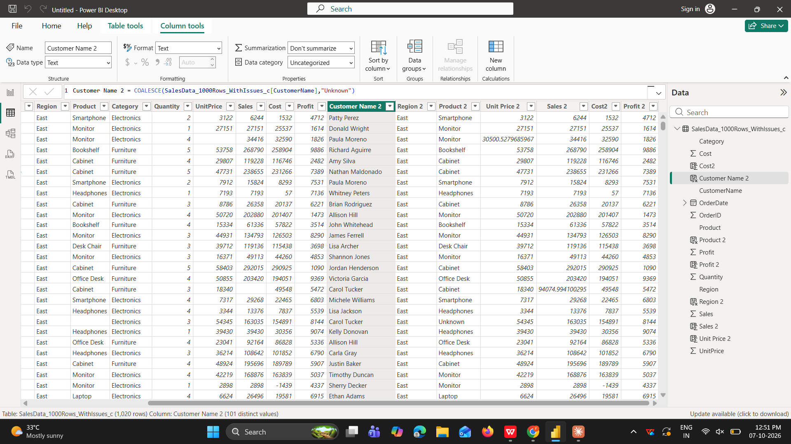
- Removing duplicate rows.
Before
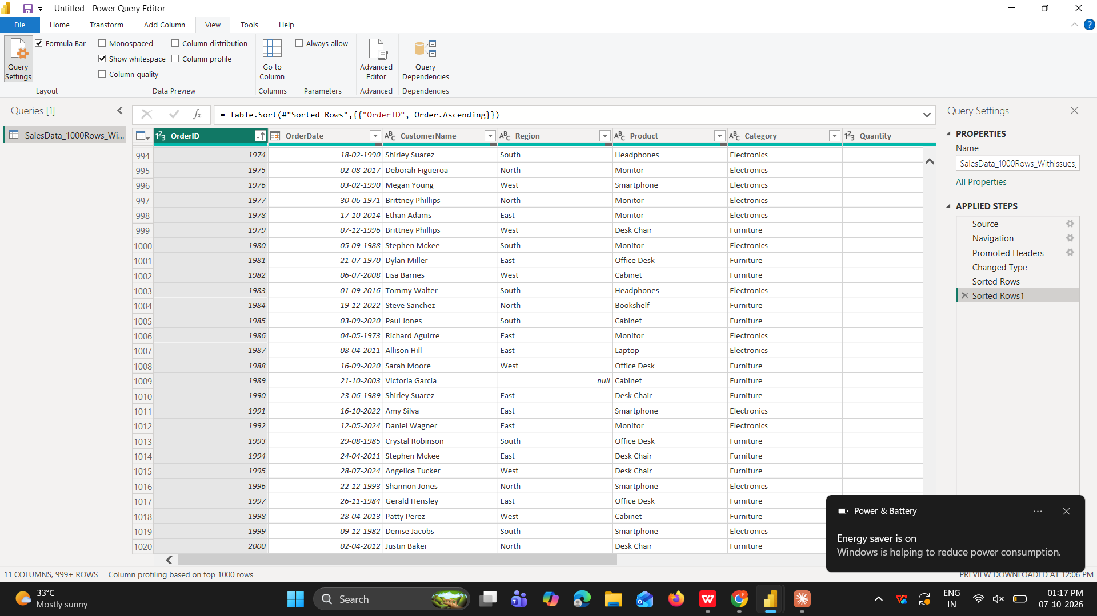
After
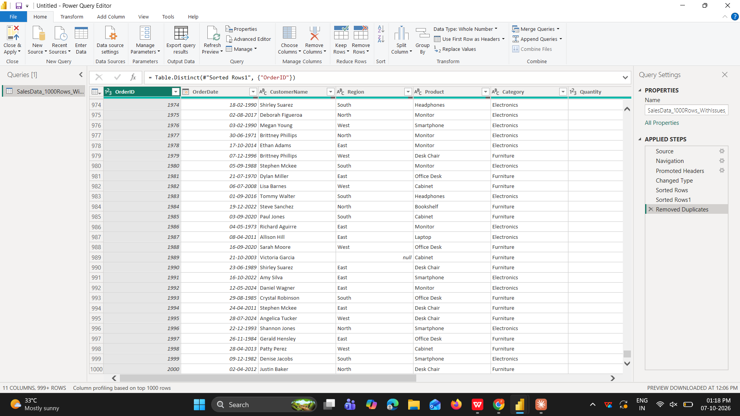
- Standardizing the OrderDate column to a consistent date format.
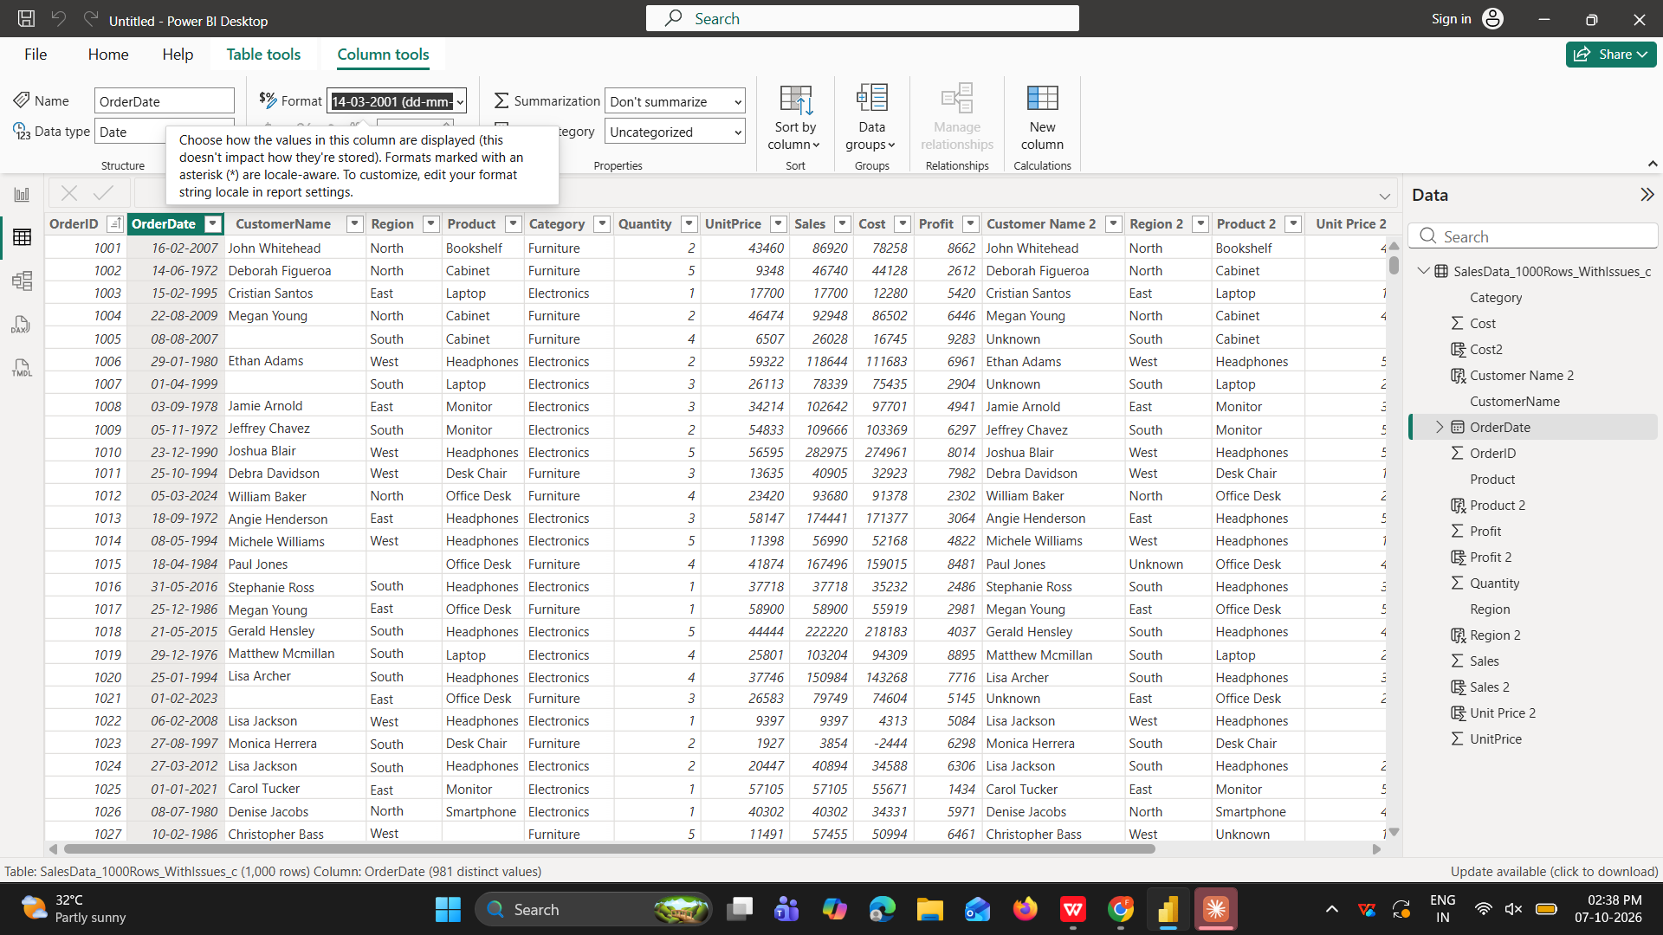

Q2: Visualizations and Insights
- Create a Pie Chart showing order distribution across different regions.
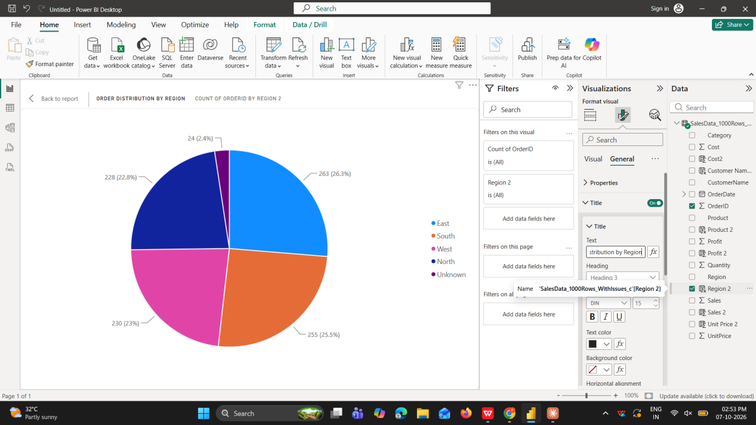
- Create a Column Chart to display the top 5 trending products based on the number of times each product was ordered.
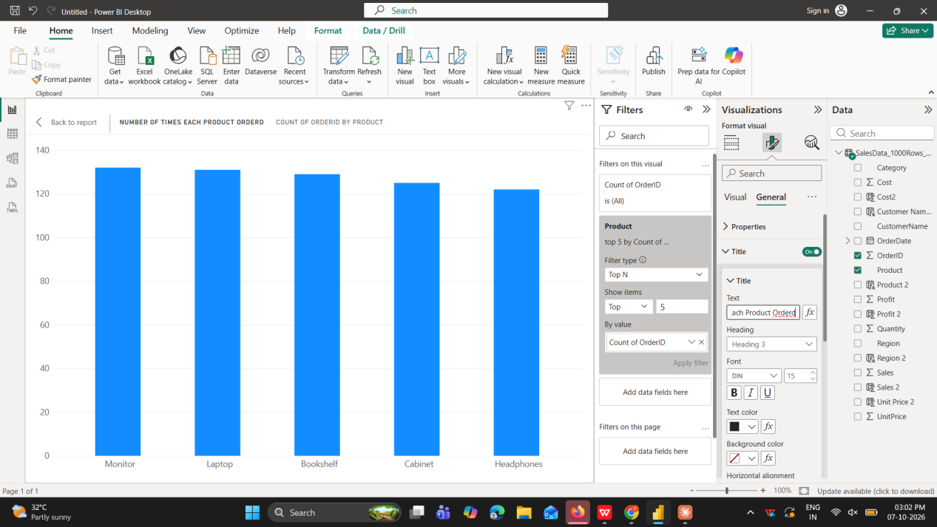

- Create a Line Chart to show the profit trend over time.
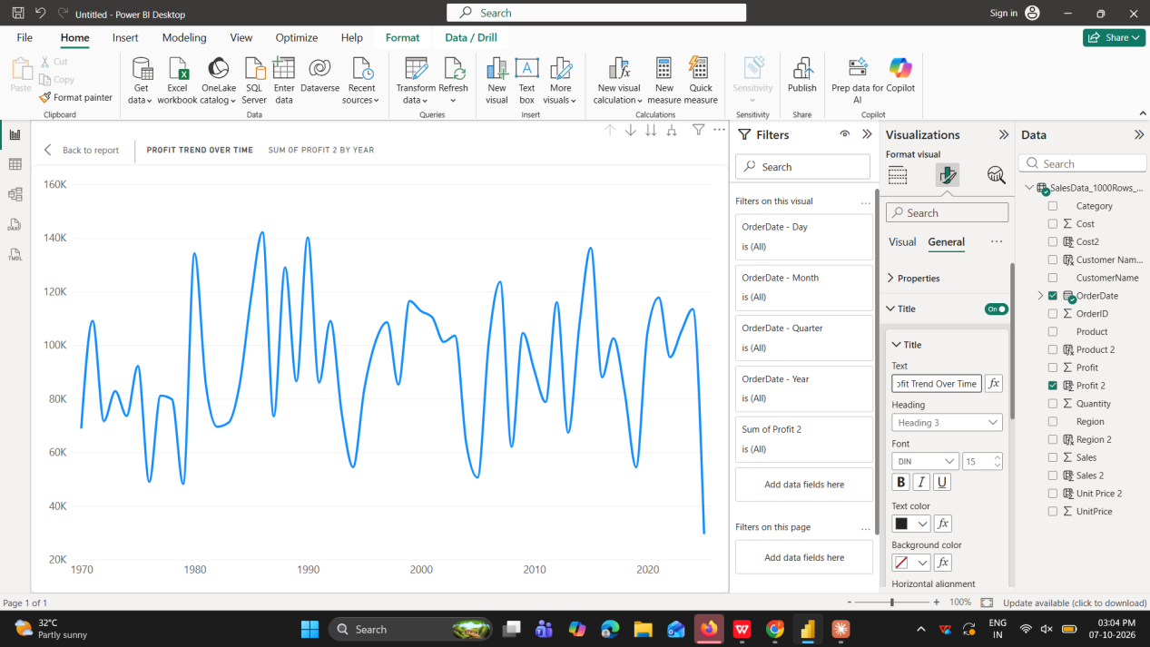

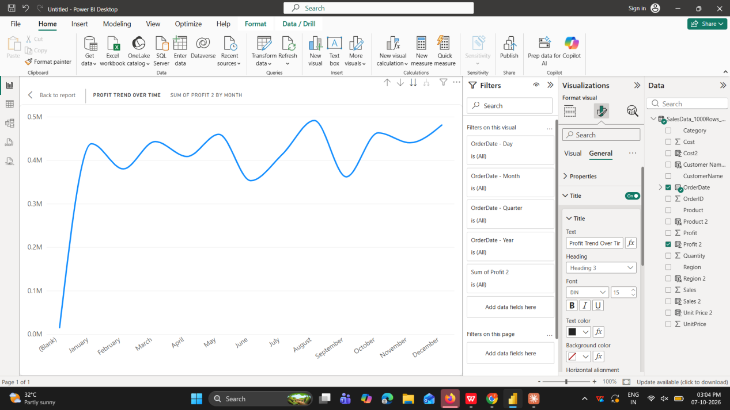

Q3: DAX Calculations
- Create a Calculated Table named EastRegionOrders that filters and displays only the orders from the East region.
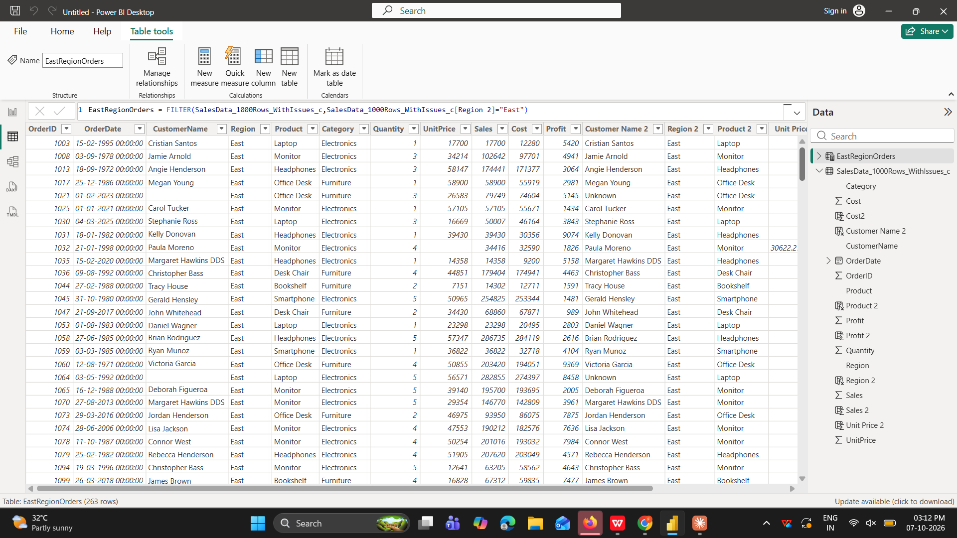
- Create a Calculated Column to compute the difference between the Profit and Cost columns. Name it ProfitCostDifference.
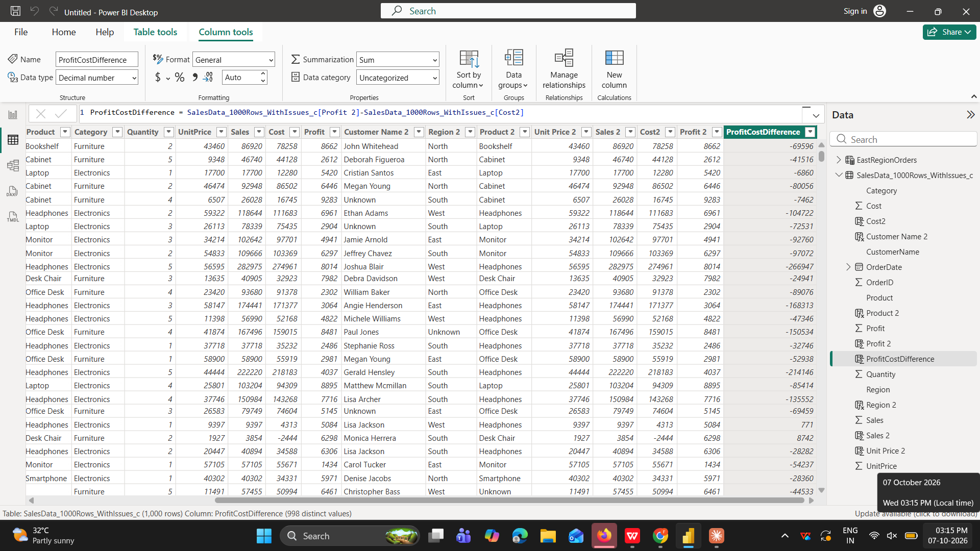
- Create a Calculated Measure to find the total profit earned. Name it TotalProfit.
